  - Liite, Koulupuutarhavuosi 4-5

Siementen leviämistavat
Millaisiin ryhmiin siemenet voidaan jakaa niiden leviämistavan perusteella?
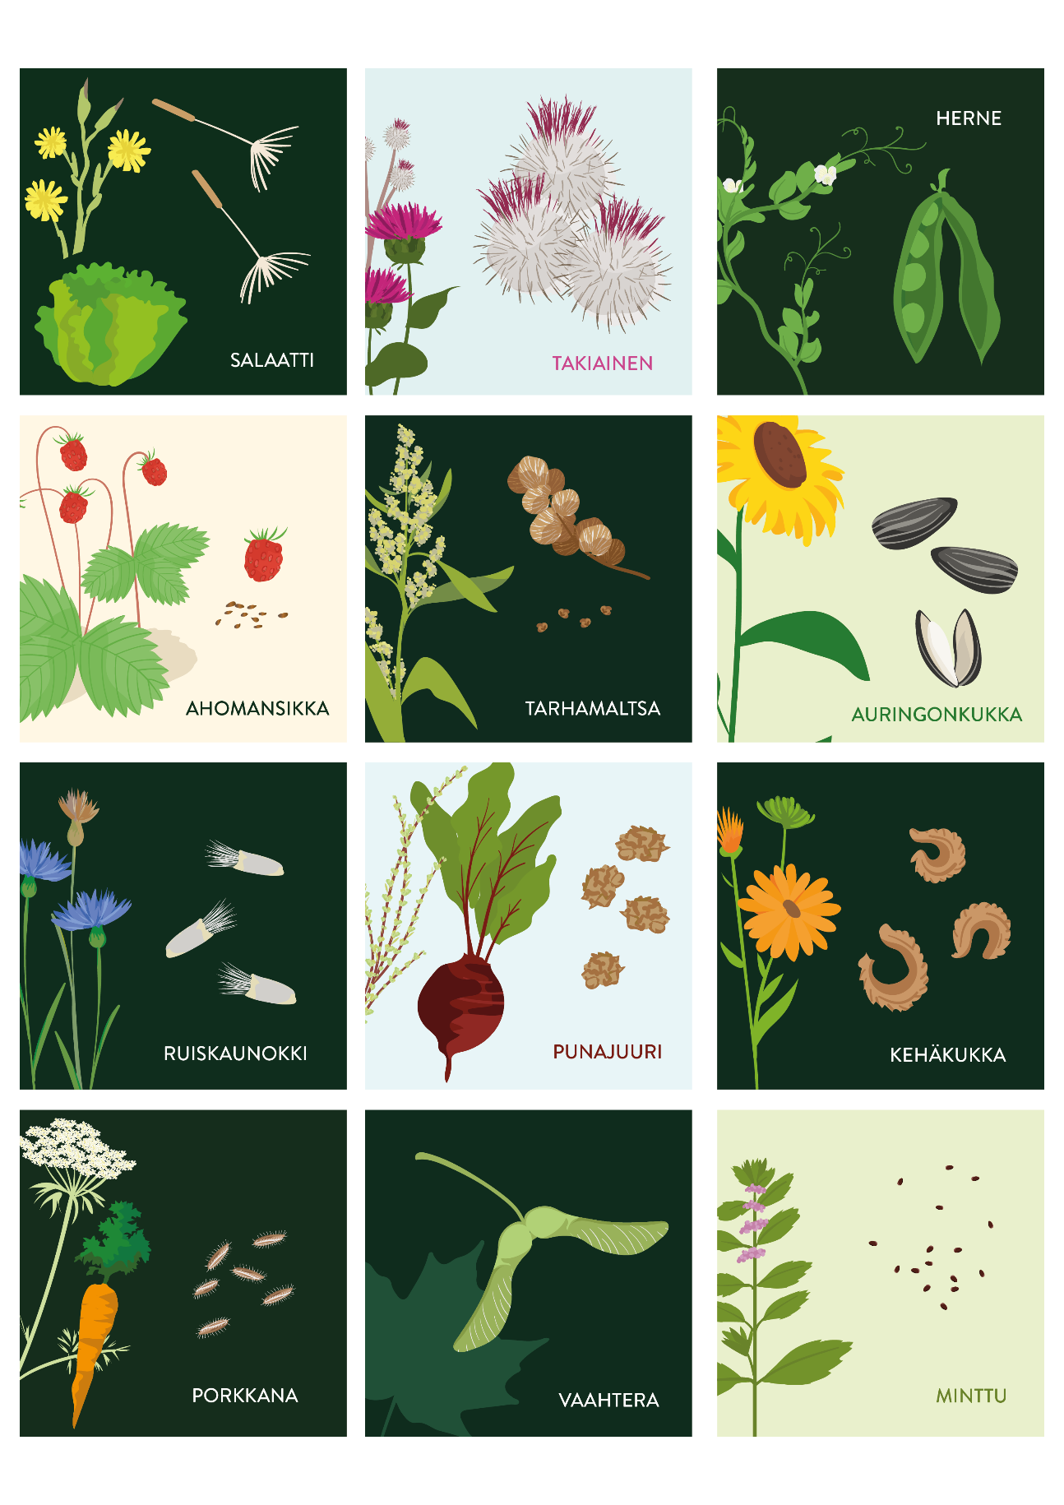

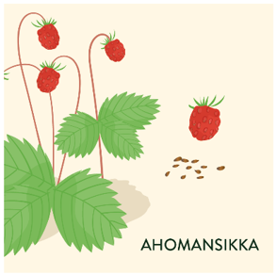
Kuvaile viittä yleisintä tekniikkaa. Mitkä ovat kasvien strategiat?
_________________________________________________________________
_________________________________________________________________
_________________________________________________________________
_________________________________________________________________
_________________________________________________________________








