  - Bilaga Trädgårdsår 4-5

Fröspridningstekniker
Hur många olika frötyper kan du hitta?
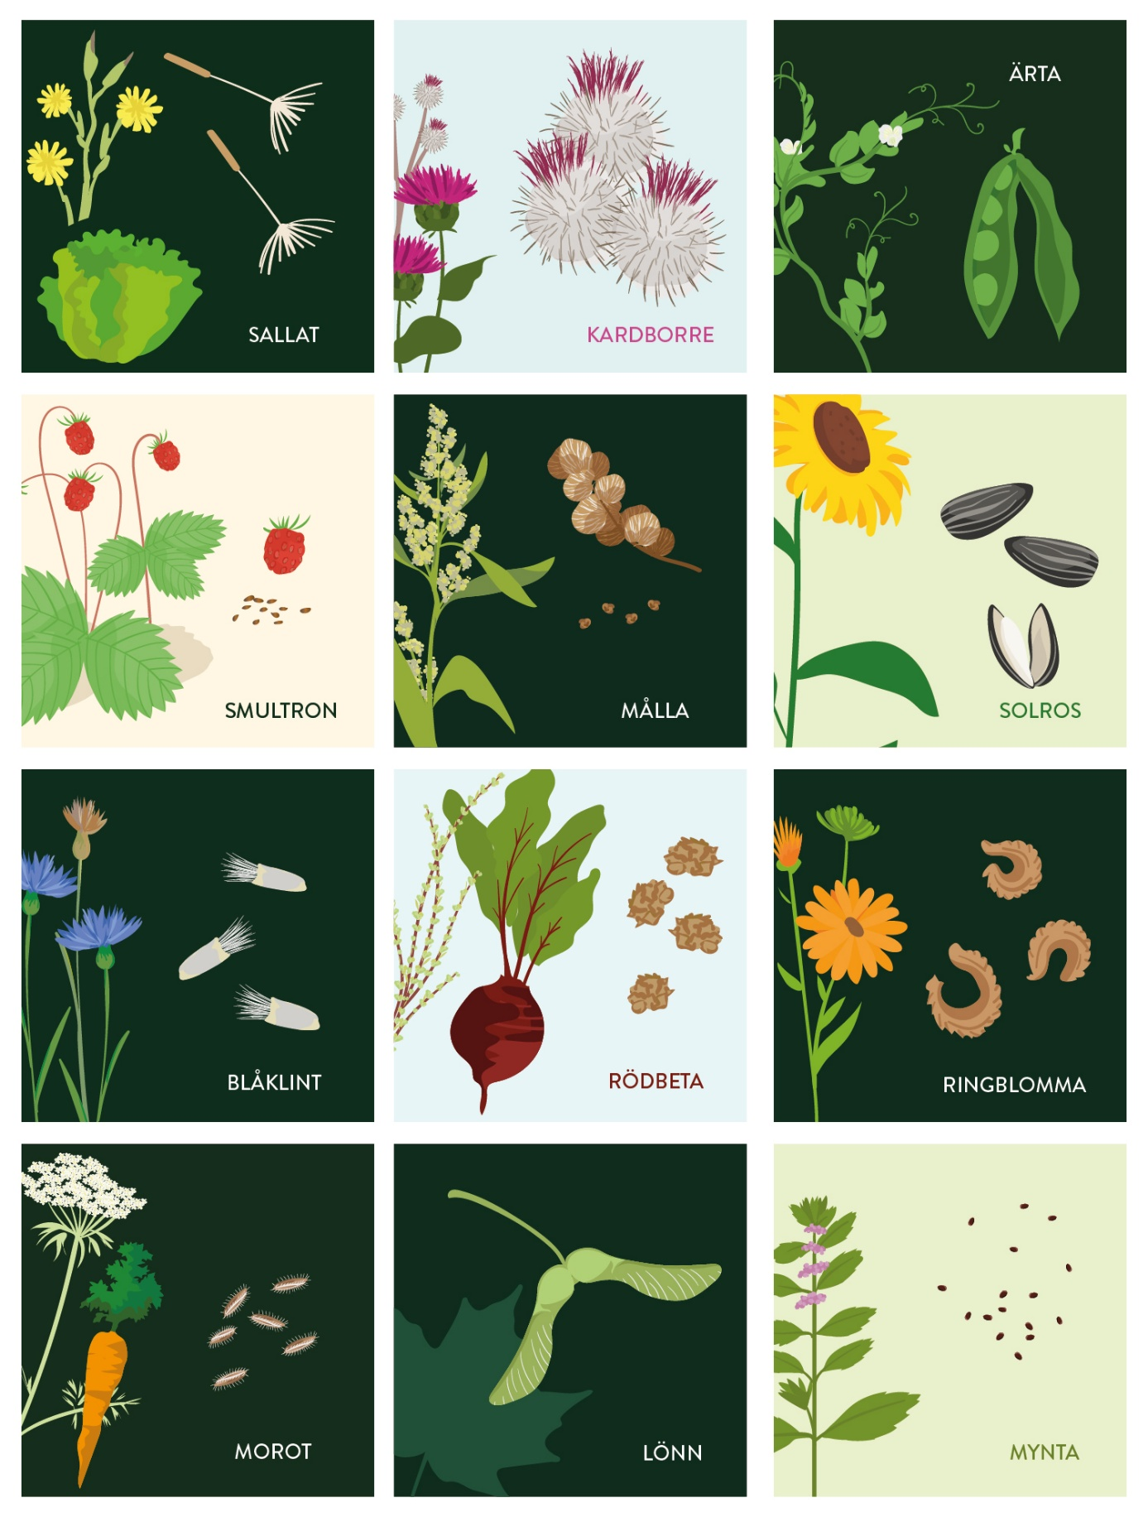

Beskriv de fem teknikerna. Hurdan är växtens strategi?







